OUTPUT OF THE STUDENT JDBC PROGRAM.

- Output for a menu-driven program in JDBC for student database.

- Inserting details of a single student.
>>console:-
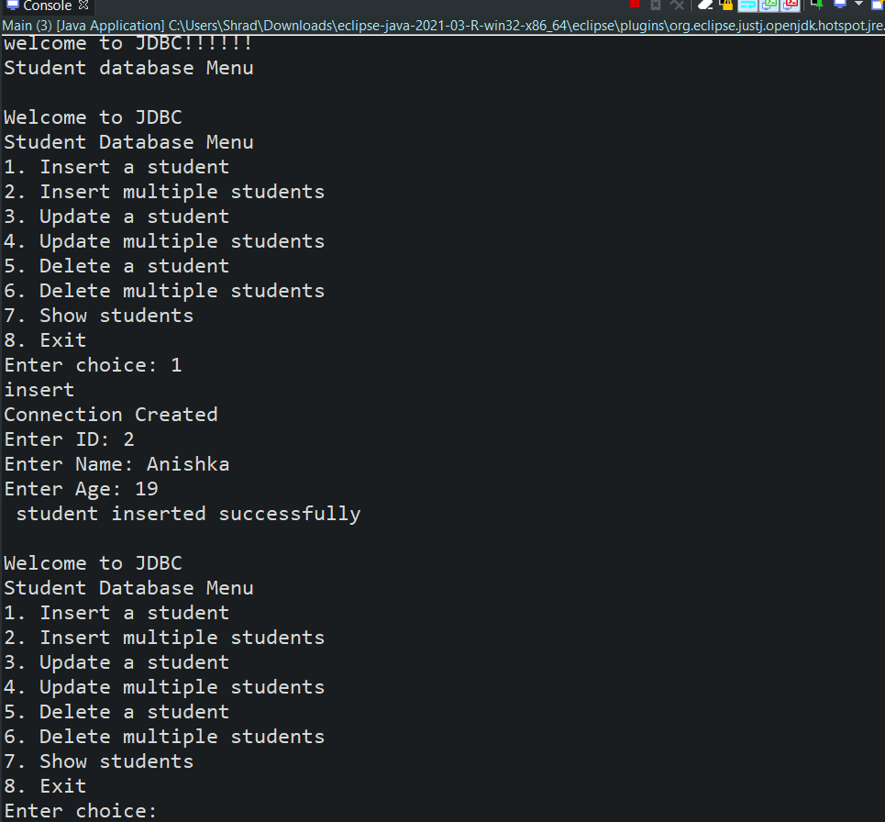

>>>Mysql command line output:-
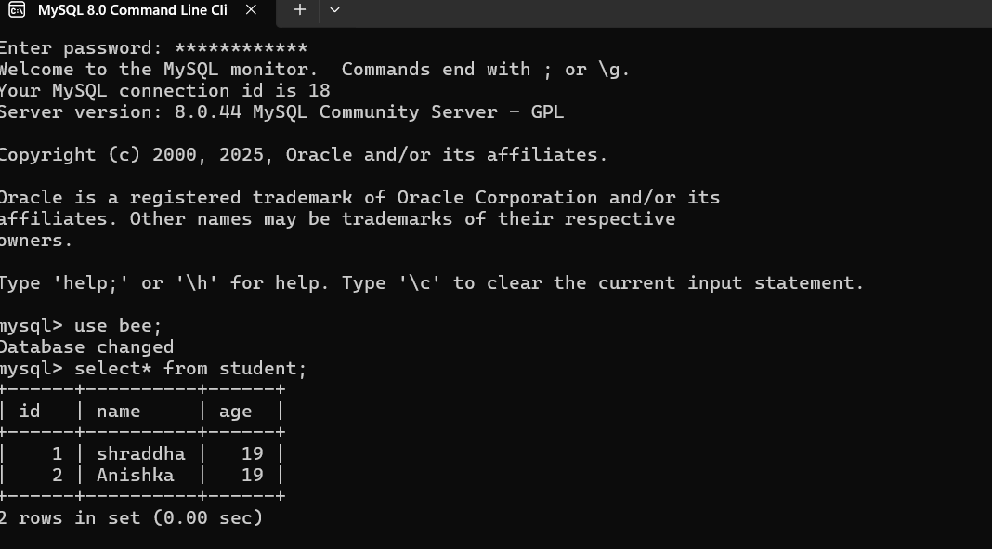

SUCCESSFULLY INSERTED!!!
2.Insert multiple student’s details.
>> console:-
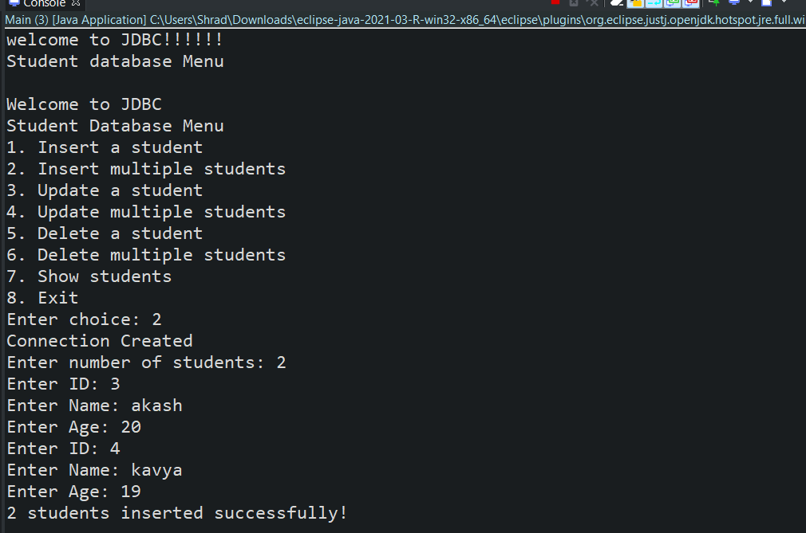
>>MYSQL COMMAND LINE
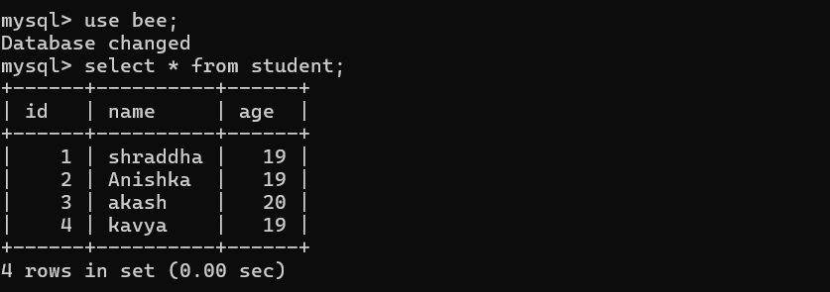
SUCCESSFULLY INSERTED 2 STUDENTS!!
3.Update a student details.
>>console:-
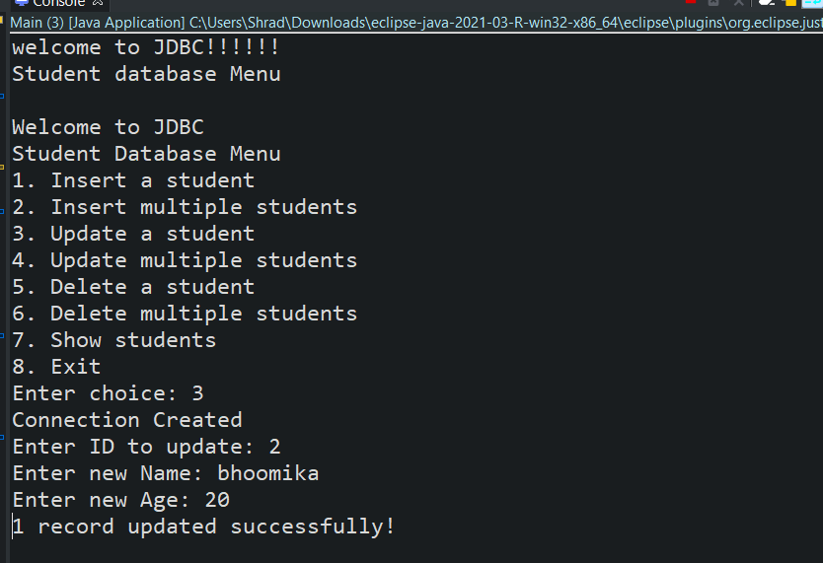
>>MYSQL COMMAND LINE
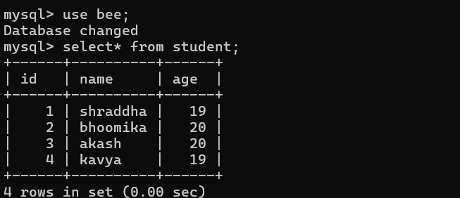
UPDATED ID=2 DETAILS!!!
4.Updating details of more than one student.
>>console:-
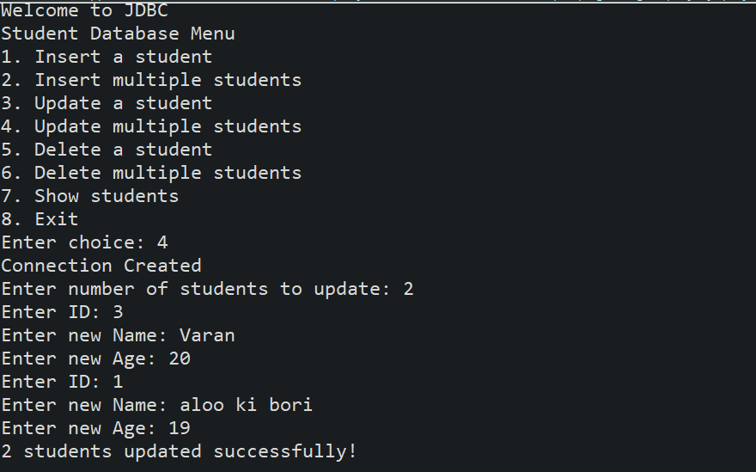
>>MYSQL COMMAND LINE:-
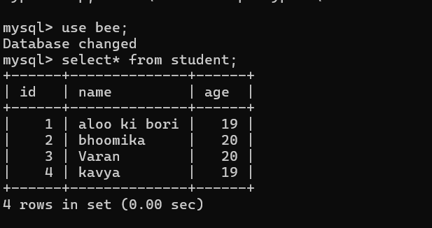
SUCCESSFULLY UPDATED DETAILS OF 2 STUDENTS!!!!
5. Delete details of 1 student.
>>console:-
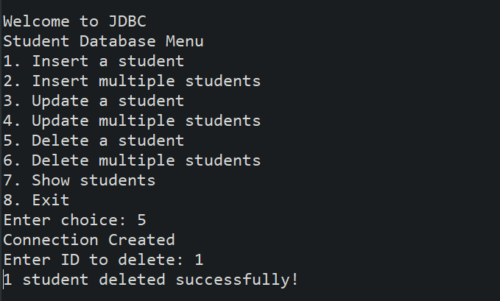
>>MYSQL COMMAND LINE:-
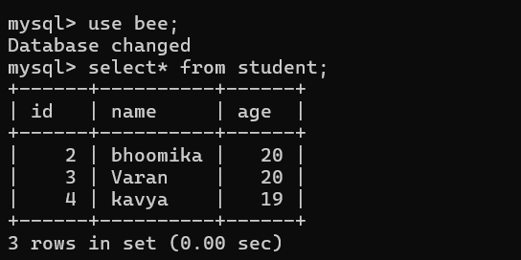
SUCCESSFULLY DELETED DETAILS OF ID=1!!!!
6.Delete multiple student details.
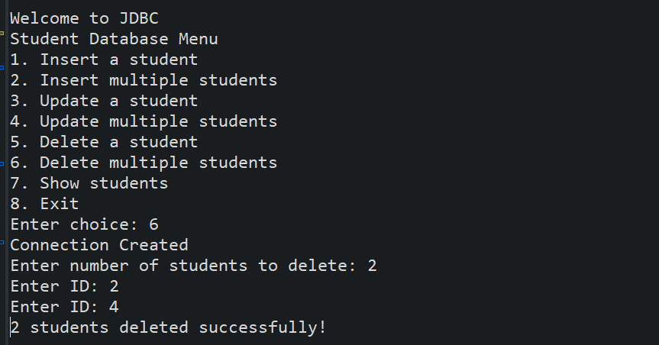
>>MYSQL COMMAND LINE:-
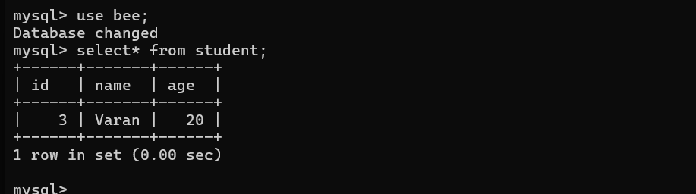
SUCCESSFULLY DELETED 2 IDs DETAILS!!
7.Show Students .
>>console:-
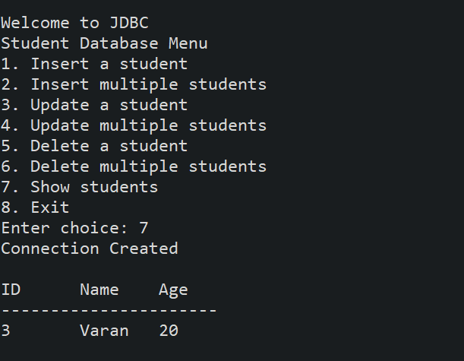
8.Exit.
